**YOUR TAROT RESULT**

**First Position: Do Our Souls Already Know Each Other - 2 Of Wands**

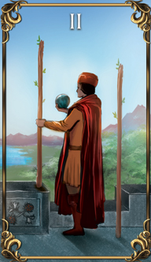Things are about to start getting equal and balanced when the Two of Wands appears! This card doesn't promise that your souls already know each other, but it does hint that it's possible. Even if there's no previous soul connection, this person's spirit is very good for you, and will teach you something that your own soul agreed to learn. Before you can have a successful relationship with anyone else, though, you have to have a good relationship with yourself. Souls who already know each other don't always recognize each other immediately, so give it time and see where it goes.

**Second Position: Should I Invest My Time In This Relationship - King Of Wands**

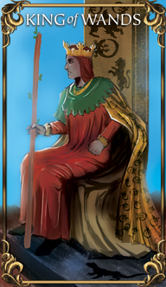Everything about the King of Wands assures you that you're confident and appealing. It would be easy to think that, with all this charm and charisma floating about, that this person is definitely worth your time. However, a lot of that is just chemistry, and it's going to take some patience to differentiate what's harmonious and what's just hormones! There are going to be some challenges with this coupling, but if it's meant to be, then those challenges are part of the ‘getting to know you' process, and part of the reason you've met up with each other in the first place! Don't get too cocky or self-assured about the future when this King appears. Part of the energy between the two of you might be a lesson in humility!

**Third Position: How Does The Future Of This Relationship Look - The Star**

This is a very good omen where relationships are concerned! It brings hope and encouragement. If you're looking to settle down and to deepen an existing connection, this card brings welcome improvements. It's a promise for the future, as well as an asset for whatever you two are going through at the moment. There's every hope that this is going to be a long-lasting connection, so invest in it sincerely and openly and don't hesitate to make your plans for the future. Even if it turns out that this relationship isn't permanent, it will be valuable, so don't hesitate to put your time and energy into it. The Star promises that this is something that's worth pursuing.